Week 01

This document and the others in this series are my way of tracking each assignment, anything helpful for remembering the concepts, my plan on getting it done, the challenges I had along the way, and how I solved them. For this assignment, I had a rubric structuring a proper development environment. I activated my student editions of the IDEs and got to work. This was going to be my first time revisiting Python-based programming and a complete beginner to machine learning and AI.

Recommended Readings/Videos:

Slides

Lecture Week 01

Readings

AI vs. Machine Learning vs. Deep Learning
Concentric (sharing the same center, encompassed by larger thing) relationship between the three and highlights the role of Neural Networks and Deep Learning.

AI: Anything that allows computers to mimic how humans learn.  ML: Subset of AI that learns from data without explicit programming.  DL: Subset of ML that uses neural networks with multiple layers.  Neural Networks: Computational structure that powers DL, which is inspired by the human brain. Neural Networks are like mathematical functions that transform inputted data into new outputs through layers of “neurons” and interconnected nodes.  DL requires substantial data and computational power. AI models have increased the demand in tokens - the atomic units of intelligence. | 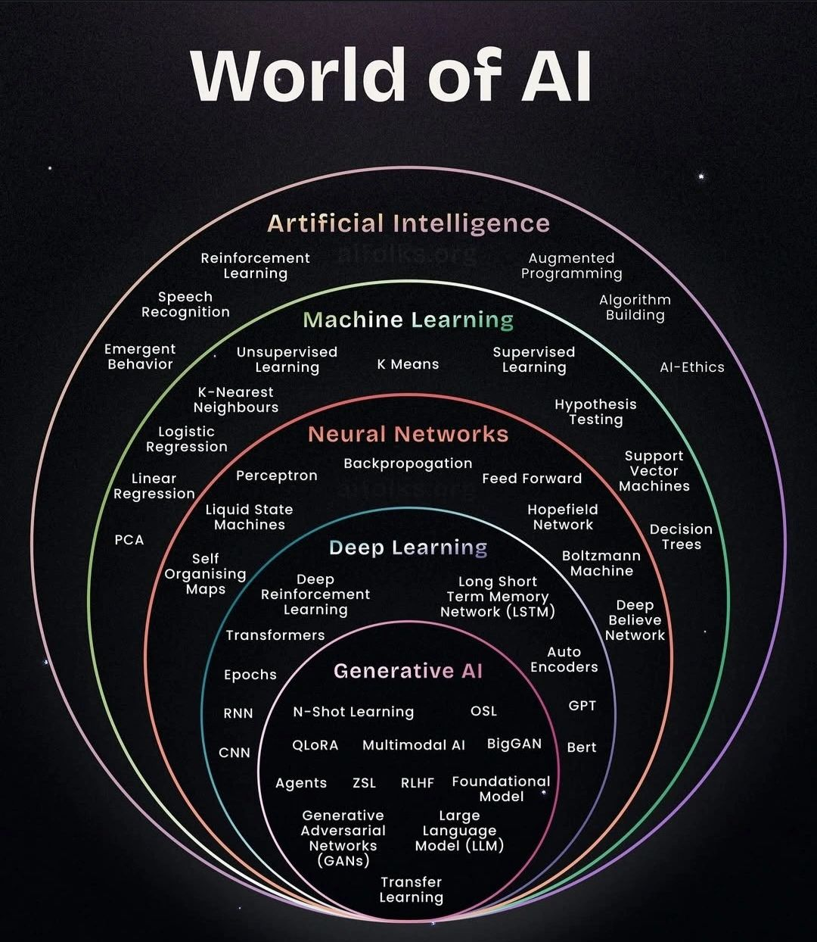

Difference Between AI, ML, and DL:
Nested concepts: AI broadest category, ML subset of AI that learns from data w/o explicit instruction/programming, DL is a subset of ML using neuron networks + multiple layers, and neural networks themselves are the computational structure that power deep learning (DL).

Inspired by human behavior of learning, neural network models based on the brain, and DL has led to a lot of advancements. Historically, AI was hard-coded rules (i.e expert systems) but now are moving towards data-driven ML methods. “Deep” in DL refers to the many layers in neural networks. Deep neural networks need to go through their own “training” phases. These AI models get an education the same way humans do - in order to complete a task or do a job. GenAI models use these neural networks to identify patterns and structures within the existing data to generate new content.

The main goal of AI is to have computers infer from knowledge, so these neural networks are presented with data and asked to make sense of it. “AI Inference” is where the trained AI model generates new outputs using reasoning and making predictions. Human neurons can connect to other neurons within a certain distance, but artificial neural networks (ANNs) have separate layers, connections, and directions the data flows through.

When training the neural network, training data is put into the first layer and neurons assign a weighting to the input based on how correct or incorrect it is in the context of the task being performed. If you were to make an AI assistant, the model might first learn user intent and map relationships between natural language instructions and code. While other layers will take it to a deeper understanding of syntax, autocompleting functions, or even suggest snippets. In the final stages, the code can be reviewed for accuracy and refine the output. Each layer builds upon the last and the model is “rewarded” for how closely the output matches the desired goal.

How would you describe the differences between AI, ML, and DL to a non-technical stakeholder? What defines hand-coded AI from a ML approach? Why is DL becoming more relevant now?

Think Russian nesting dolls with AI being the biggest, ML being in the middle, and DL being the smallest.
AI - ANY technology making computers act intelligently
ML - computers learning from examples and inputted data rather than hard-coding rules
DL - complex neural networks for difficult tasks like image/speech recognition

HAND-CODING is where the programmer writes every rule manually
i.e (IF email contains ‘FREE CAR’ THEN spam)
This means it has a limited scale and doesn’t adapt to other scenarios. However, a ML approach would look more like:
Feeding 1,000 SPAM emails and then feeding it 1,000 legitimate emails so it forms a pattern recognition. This makes it more adaptive and it can scale with larger counts of emails.
(Human writing logic vs the computer discovering the logic)

DL is more relevant now than ever because of access to LARGE amounts of data and DL loves eating up data and working with it. Computing power is now more affordable and cloud computing makes it easier to run these models.

Early on, expert systems were hard-coded logic and limited by the need to manually program every rule. Machine-learning era introduced computers learning patterns from inputted data and using early algorithms like decision trees and support vector machines. SVMs were supervised machine-learning models that find the best boundaries (called a hyperplane) to classify data by maximizing the margin between data points of different classes. Look into the “kernel trick”.
Later on, Deep Learning brought with it neural networks with many layers and enabled by better technology, advancements in GPUs, cheap access to cloud storage, and improved algorithms.

Defining the difference between Narrow/Weak AI
Narrow/Weak AI  - Specific, limited tasks  - Limited to its programmed function  - Common with assistants and chatbots  - Simulates intelligence for specific purposes  - Good examples: Siri, Alexa, image recognition software, etc. | AGI/ Strong AI  - Perform any intellectual task that humans can  - Theoretical so does not exist yet but a current goal  - Capable of learning, reasoning, abstract thinking, and adapting to new situations  - Human-like cognitive abilities and self-awareness, consciousness  - Similar to teaching it a new skill and it used the knowledge gained to solve a completely different problem

Different Learning Paradigms

Supervised Learning  Learning from labeled examples (input-output pairing)  Similar to how we learn with flashcards or with study guides where you are provided correct answers  Data is required with a labeled dataset (i.e the image paired with a label of “dog”)  Predict the outputs for new, unseen inputs. Useful for classification (spam detection) and regression (i.e price predictions) | Unsupervised Learning  Find patterns in unlabeled data  Similar to solving a puzzle without the picture on the box  Raw data with no tags  Discovers hidden structures (clusters and associations)  Used for customer segmentation, anomalies, etc. Hard to decipher HOW the computer learned this or how it reached the conclusions it has | Reinforcement Learning  Learning through trial and error with rewards/punishments  Similar to training a dog with treats  There has to be an environment where decisions made with the data leads to rewards or penalties  Learns optimal behaviors to maximize the reward  Great for playing games, robotics, or autonomous vehicles

What learning paradigm would be useful or recommend products to customers and why? Why is supervised learning considered easier to implement than reinforcement learning? What is a scenario where you could combine multiple paradigms?

Supervised learning is great combined with unsupervised learning. Supervised because you can input customer data like purchasing and browsing history, ratings, etc. The output would show likely items they would buy and the training data can use historical data of purchased/liked items. Labeled data works here because you have information like “past purchases” and there is a clear input/output relationship. As you collect more purchase data, the pattern recognition gets better at predicting what a customer would purchase. There are clear right/wrong answers.

Unsupervised learning is great for clustering similar customers together, discovering hidden patterns like people who shop during certain times or are “bargain bin divers”. Examples of clusters would be a group of young professionals with high disposable income and buys premium brands, another group could be budget-conscious families that buy in bulk and during sales, and the third group could be early adopters of technology or enthusiasts who invest early in a product. Learn when users might want a specific response, detect unusual activity, or group similar things together without explicit labels.

Reinforcement learning is more difficult to implement for this use case because it is more complex, needs live interaction and constant feedback loops, slower to train, and a lot harder to debug. It can be useful, however, for dynamic pricing where you can convert it in real-time, real-time bidding in ad placements, and long-term customer engagement value. It has more delayed, indirect feedback. It requires an environment to interact with and can be hard to identify issues. Requires interacting with the environment, generates data through trial/error and requires simulator or real-world testing.

Combining paradigms would be useful for combining strengths for different problems. For example:

Paradigm | Best For | Weakness
Supervised | Known patterns, labeled data | Can’t discover new patterns
Unsupervised | Finding hidden structure | No specific task optimization
Reinforcement | Sequential decisions, adaption | Slow, complex, needs interaction

Long story short, use Supervised for what you know, use Unsupervised for what you don’t know you don’t know, and use Reinforcement for what changes over time. A good example of combining all 3 would be autonomous driving or for medical diagnosing equipment.
Data Types and Operational Concepts (Inference, Bias)

Key Concepts:

Structured vs Unstructured: Structured is organized in tables/rows/columns similar to Excel spreadsheets. They have a fixed schema (predefined columns) and are labeled to be easy to search and analyze. They fit well in traditional databases (SQL). Unstructured has no predefined format or organization, is more freeform and flexible which means it needs to be processed first before easier to analyze. A lot of data in the world is unstructured. Semi-Structured has some organization but does not have a table format. It can contain tags or markers and is a little easier to process than unstructured data.

Structured Examples: Customer Database w/ columns (Name, Email, CustomerID, etc.)

Unstructured Examples: Text document, blog posts, podcasts, videos, images, etc.

Semi-Structured Examples: HTML web pages, email with header but unstructured body message, XML/JSON etc.

Numerical/Categorical: Data is represented by numbers and you can perform mathematical operations with it. For example, Continuous Numerical Data can have infinite possible values because you can take any value within a range. Will likely be measured on a scale, have decimal points, and can be infinitely precise. For example average temperatures, weights, heights, distances, prices, etc. Discrete Numerical Data has specific, countable values with no in-between so are usually whole numbers, counted and not measured, and a finite number of possible values within any range. For example these could be the number of people in a line, the number of bedrooms in a house, the views on a YouTube video since there aren’t .5 views. Categorical Data is data represented by labels/categories where math doesn’t make sense. The number, if there is any, is a label and not an actual quantity. For example, something that cannot be sorted but doesn’t have an inherent order. A blood is not “lesser than” B blood, Blue is not “greater than” blue, etc. There may be an order to the HTTP process of GET, POST, PUT, DELETE but ‘GET’ is not less than ‘POST’ for example.

Data Type | Can Use | Example Algorithms
Numerical | Math operations (mean, std dev) | Linear regression, neural networks
Categorical (Nominal) | MUST encode | Decision trees
Categorical (Ordinal) | CAN encode w/ order still in tact | Decision trees, ordinal regression

Nominal categories DON’T make mathematical sense, but Ordinal categories DO have meaningful order or ranking.

Labeled/Unlabeled Data:

What is batch inference? How does it work?
First, INFERENCE is the process of turning tokens into intelligence. BATCH INFERENCE is the process of making predictions on a large collection of data all at once. For example, instead of processing requests individually in real-time, these large batches can be scheduled in intervals. Instead of a teacher grading as students turn in their tests, the teacher can designate time on the weekend to grade a stack of 100.

Happens in steps:

- Accumulate the data (over a time period i.e daily, weekly, monthly, etc.)
  - Store this data in a database
  - Nothing has been done with the info yet, just collecting
- Trigger Scheduled Task
  - Automated tasks scheduled (i.e every day at noon)
  - Use Airflow, cloud scheduler, etc.
- Load & Process
  - Retrieve ALL data
  - Load the ML model
  - Process the data in large batches (i.e 1,000 at a time)
- Generate Predictions
  - Model makes predictions based on data records
  - Store the results in the database or cache to be used shortly after
- Results are Available
  - Predictions are now ready to use
  - Dashboards can display and consume the results
  - Valid until another batch run completes

Explain difference between:

Batch Inference (high throughput, high latency, scheduled)
Batch Inferences are in scheduled intervals, can take minutes to hours to do, the throughput can be millions per batch, deals with LARGE data sets, scheduled jobs and tasks to do, very very low cost prediction, results can be delayed in terms of not being immediate, and are great for reports/analytics.

Real-time Inference (low latency, immediate response, continuously running)
These are more on-demand per request, can take milliseconds to complete, the throughput is dozens per second, usually for individual requests, servers are constantly on to run these, the cost prediction is higher but the results are fresh, which makes them excellent for user-facing decisions.

Bias in ML and its different sources (data-driven, interpretation-driven) and the ethical implications. Biases are systematic errors in predictions that unfairly impact certain people which leads to discriminatory outcomes and results. These can be recognized with consistent patterns that harm specific populations.

Data-Driven Bias is where it is embedded in the data itself. If there is discrimination in historical data, it can be reflected by those past decisions and the model ends up perpetuating the same ideas. If you want AI that screens for certain things but most of the data is from a dominant group, the marginalized group won’t be represented in the data leading to inaccuracies. There are usually underrepresented groups and flawed data collection.

Interpretation-Driven Bias come from human decisions in designing and deploying systems. For example, an algorithm was used by US hospitals on 200M people where they showed black people were receiving less care due to access barriers and thus the statistics were skewed to show at ‘less risk’ of conditions. This can create an oversight where they are not diagnosed correctly.

Ethical Implications can amplify the inequalities that already exist, can create biases in tools responsible for hiring workers, finding qualified candidates for priority healthcare, or discriminatory housing practices. These biases can compound over time and train itself on similar data to continue the cycle, this can cause all sorts of human/civil rights violations. It can create ‘feedback loops’ where these ideas are echoed, destroys trust in our own technology, and harms vulnerable populations.

These systems are NOT neutral, they rely on us to pay careful attention to bias, to address these issues with technical solutions, and ongoing monitoring.

Week 01 DevSetup
- Installed Python version 3.13.5, used -m pip install to download numpy, pandas, matplotlib, seaborn, scikit-learn, jupyter
- numpy does math/number operations, pandas uses data tables/dataframes, matplotlib.pyplot can create basic plots/charts, seaborn makes the plots a lot nicer looking, sklearn.datasets gives access to iris dataset
- Created folder ‘AI-ML-DevSetup’ on desktop
- Created Jupyter notebook ‘IrisSet’ and copied file to new directory
- Imported dependencies, loaded Iris Data Set, Print first and last 5 rows to see flower measurements and species
- Loaded the dataset, converted it to table with pd.dataframe(), named columns, add species numbers
- Check data types (floats), describe() gives summary
- Added box plot with petal length by species
GitHub: https://github.com/givecoffee/01-AI-ML-DevSetup

Note:

To reopen Jupyter notebook, open command prompt and run:
jupyter notebook or launch through anaconda navigator

Anaconda Navigator > ai-ml-devsetup environment > create version control cell

Posted version and info in README and pushed to GitHub

Afterwards, refactored with Anaconda Assistant and fixed errors

